User stories from Krauthammer Lab at Yale., as captured after the 11/23/2010 meeting.

=========================================================

Priority – 2

User Story Title: Annotation on sample data.

The basic idea here is allow the study manager to provide annotation data on each sample. This annotation data would then be queryable. Examples of annotation data are “disease state”,

As a study manager role, USBAT upload a file providing annotation for a sample ID. The file format will be similar to the subject annotation file that is currently used except that the sampleID will be used as the identifier. The process will work similarly to the way that image annotation works in that first a genomic source is configured and loaded, and second, the genomic sample annotations are added. If user selects the checkbox for “Create a new definition if one is not found” , and the definition does not exist for this annotation name, then one will be created automatically. The sample annotation name will be added to a default annotation group.

As a study manager role, USBAT group the sample annotation names using the existing Annotation Groups facility. USBAT see a new annotatio source called “sample”.

As a study investigator role, USBAT add sample annotation to a query by selecting the corresponding annotation group name which contains the sample annotations. (like is done at present).

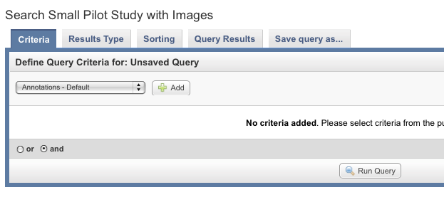

Continuing the query creation, by selecting a sample annotation name and value, will then result in the only those matching samples being considered in the query.

=======================